Report part II

Break in: couldn’t get to sell anything for anything

Liked **Break invaders** but didn’t get a very high score

**Break art**. Got to a score of 75 by developing my small stagger technique with the bat. At a couple of goes the paddle turned into a worm!!! Couldn’t quite work out how to controle it before it hit something and stopped or vanished off the bottom of the screen. A couple fo times when my game ended I got this…

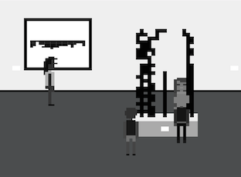

WTF?

**Breakout-2P**. Considering it took me half the game to work out how to play it I think my first score of 66 to 89 was pretty damn good. I aced the othert guy on the second time round. Love it when you push the other paddle back and they vibrate with the struggle.

**Breakout of life:** Beautiful, loved it. The pinball effect is terrific. It could be a game on its own.

**Breakout VR:** the ball falling behind the VR mask makes things a bit hard but I am getting better. My score was hidden behind the mask so don’t know how well I did. Can the two slices of white on either side be blacked or is it determined by the screen size?

**Breaktime:** Thought this was pretty funny. Maybe you could play a little longer after the first break. Got a laugh from this…

